Requirement:

Wrap fixed width text at word breaks. Given a string and a column number, return the string with line breaks inserted at the right places to make sure that no line is longer than the column number.

**Test case before the Development starts:**

**Test case 1:**

Given "The quick brown fox jumped over the lazy dog.", column 15;

Expected Returns:

The quick brown

fox jumped ove

r the lazy dog.

**Test case 2:**

Given: "Wrap fixed width text at word breaks. Given a string and a column number, return the string with line breaks.” Column 10

Expected Return:

“Wrap fixed

width tex

t at word

breaks. Gi

ven a stri

ng and a c

olumn numb

er, return

the strin

g with lin

e breaks.”

**Test case 3:**

Given: null, column 5

Expected Return: Error: Input cannot have null string

**Test case 4:**

Given: “Development”, column 0

Expected Return: Error: column must be >0

**Test case 5:**

Given: “the repetition of a very short development cycle” column 500

Expected return:

“the repetition of a very short development cycle”

Result of running the code:

The quick brown

fox jumped ove

r the lazy dog.

Wrap fixed

width tex

t at word

breaks. Gi

ven a stri

ng and a c

olumn numb

er, return

the strin

g with lin

e breaks.

Error: Input cannot have null string

Error: column must be >0

the repetition of a development cycle

screen of the program:

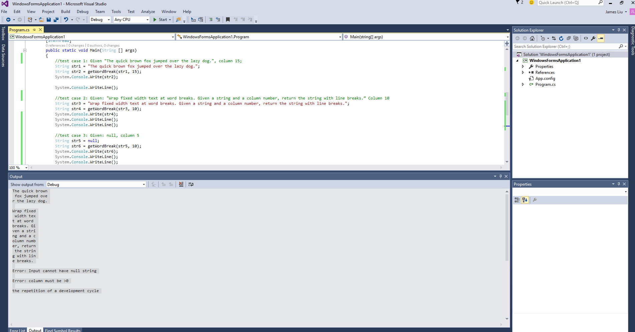

C# Source code: Program.cs

using System;

using System.Collections.Generic;

using System.Linq;

using System.Threading.Tasks;

using System.Windows.Forms;

using System.Text;

namespace WindowsFormsApplication1

{

static class Program

{

public static String getWordBreak(String input, int column)

{

if (input == null) return "Error: Input cannot have null string";

if (column < 1) return "Error: column must be >0";

//to see how many line break need to insert

int s = input.Length / column;

int flag = input.Length % column;

StringBuilder strb = new StringBuilder();

for (int i = 0; i < s; i++)

{

strb.Append(input.Substring(i * column, column));

strb.Append("\n");

}

if (flag != 0) strb.Append(input.Substring(s * column));

return strb.ToString();

}

/// <summary>

/// The main entry point for the application.

/// </summary>

[STAThread]

public static void Main(String [] args)

{

//test case 1: Given "The quick brown fox jumped over the lazy dog.", column 15;

String str1 = "The quick brown fox jumped over the lazy dog.";

String str2 = getWordBreak(str1, 15);

System.Console.Write(str2);

System.Console.WriteLine();

//test case 2: Given: "Wrap fixed width text at word breaks. Given a string and a column number, return the string with line breaks.” Column 10

String str3 = "Wrap fixed width text at word breaks. Given a string and a column number, return the string with line breaks.";

String str4 = getWordBreak(str3, 10);

System.Console.Write(str4);

System.Console.WriteLine();

System.Console.WriteLine();

//test case 3: Given: null, column 5

String str5 = null;

String str6 = getWordBreak(str5, 10);

System.Console.Write(str6);

System.Console.WriteLine();

System.Console.WriteLine();

//test case 4: Given: “Development”, column 0

String str7 ="Development";

String str8 = getWordBreak(str7, 0);

System.Console.Write(str8);

System.Console.WriteLine();

System.Console.WriteLine();

//test case 5: Given: “the repetition of a development cycle” column 500

String str9 = "the repetition of a development cycle";

String str10 = getWordBreak(str9, 500);

System.Console.Write(str10);

System.Console.WriteLine();

}

}

}

*git repo:*

*https://github.com/jamesliu1998/word_breaks*